CENWP-OD-B 12 August 2010

MEMORANDUM FOR THE RECORD

SUBJECT: Dead steelhead at the BON AFF

On 12 August CRITFC reported a steelhead mortality that was found in the BON AFF at 1100 on 10 August. On 10 August, CRITFC found a dead steelhead on the Valve 15 drain grate while shutting down the facility. CRITFC’s fish memo had noted that the crew did not notify Project Fisheries about the mort prior to sending the fish back to the river.

CRITFC provided the information below:

- Species – Steelhead
- Origin – unclipped
- Length – 63 cm
- Marks and Injuries – eye and vent damage, descaling. No tags.
- Time of Death – Unknown cause and time of death.
- Future and Preventative Measures –

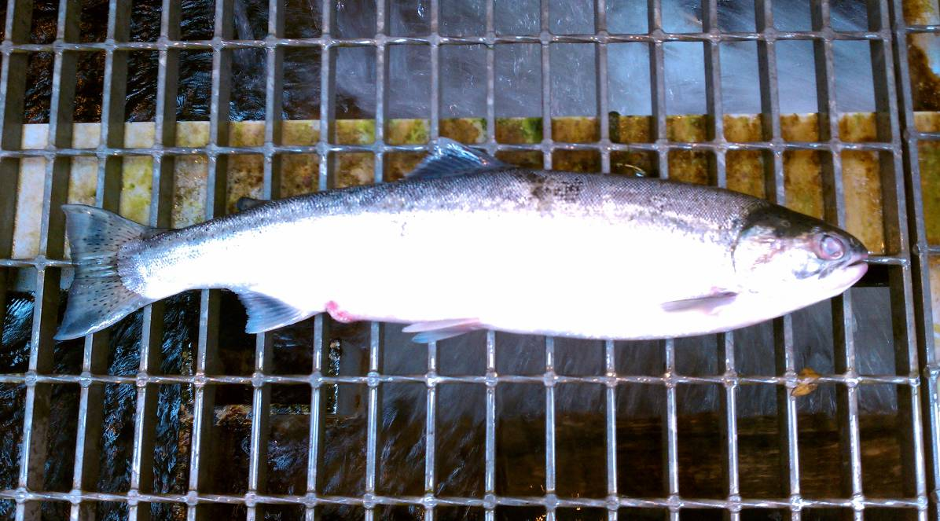

Bonneville Project Fisheries
